**Steps:**

1. **Open the command prompt navigate to the new folder you created and enter the command   
    Npm init**

**This utility will walk you through creating a package.json file. It only covers the most common items, and tries to guess sensible defaults.**

1. **Enter the command**

**Npm install mysql express nodemon cors body-parser -save**

**In order to install or update the versions of existing frameworks to avoid additional errors**

1. **Open the folder in the editor you are using. Create a file with the extension .js**
2. **Initialize and import the required modules for node. Eg: Express, mysql, cors etc..**

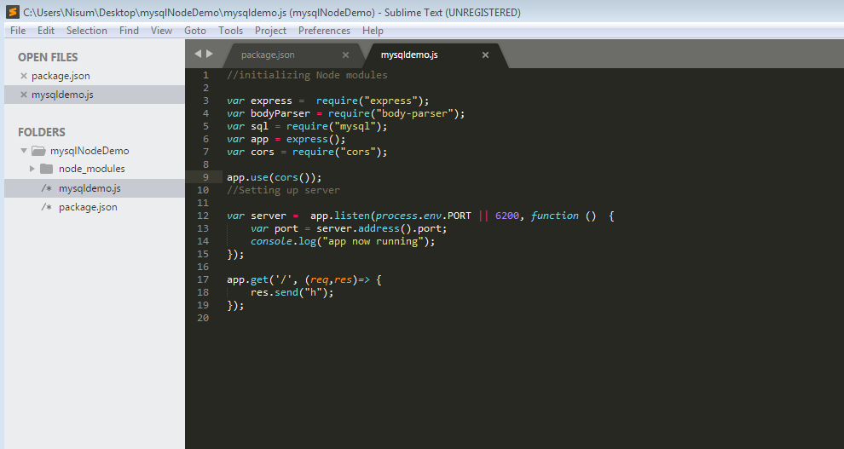

1. **Open command prompt and run the command node filename.js**

**If you want to run the server automatically try using the command nodemon filename.js(if it didn’t work try npm install -g nodemon)**

1. **To establish a connection with mysql server, write the code in app.js**

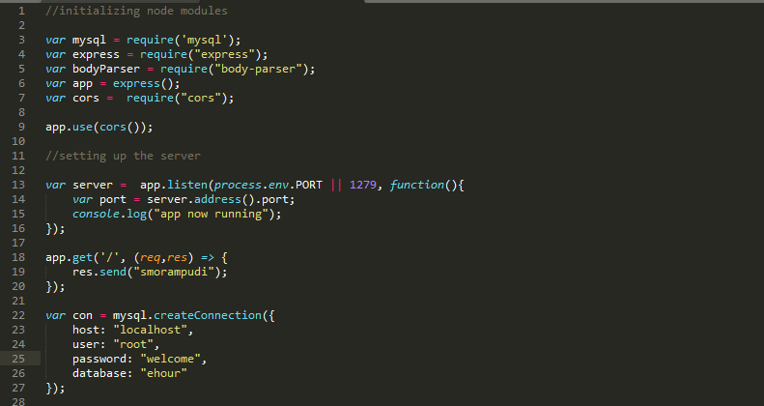

1. **This document explains about the database Mysql Server, In order to get the host, user and the password. Go to the client connection.**

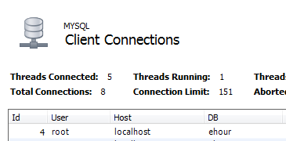

1. **To check whether the connection has established or not write few lines of code.**

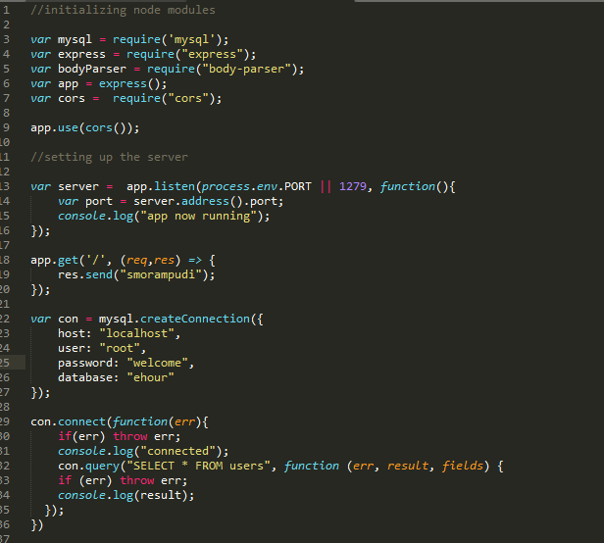

1. **Rest API’s**
2. **To get all users from the database**

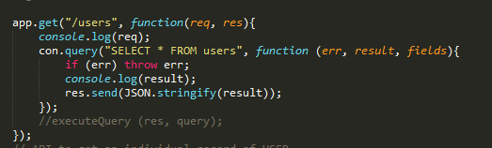

**To check whether you get the records or not type the URL with localhost:portnumber/users(in this scenario)**

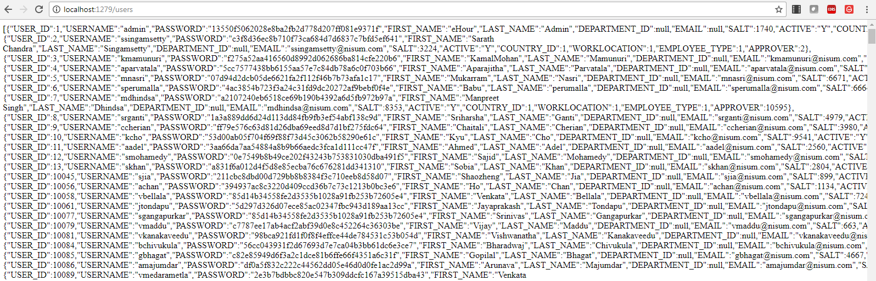

1. **To get an individual user record from the database**

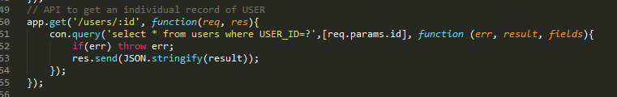

**To check whether you get the desired record or not type the URL with localhost:portnumber/users/1(in this scenario)**



1. **To post or create a new user**

### **I have fetched record from MySQL database using express, so next step will create a new entry into MySQL database table using rest api. This rest api would be a POST type because We will post some JSON data to server.**

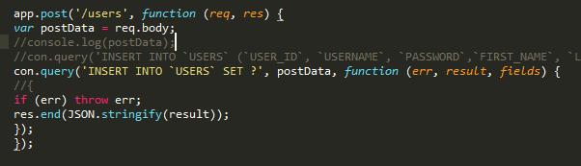

**I am testing above rest call http://localhost:1279/users/ using Postman and set json data to body, The JSON data is:**

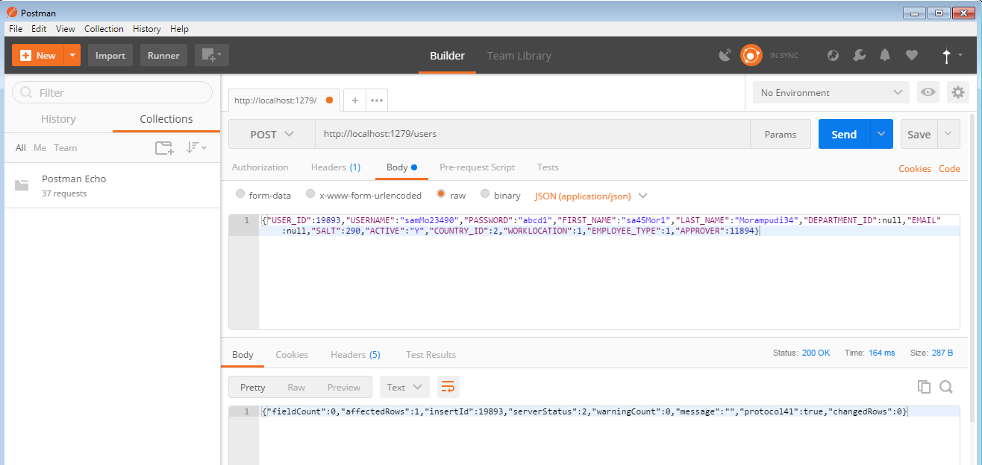

**The post method could be tricky, leading to few possible errors(which I faced)**

1. **Either a duplicate id error**

**Steps to avoid the error**

1. **Restart the node server**
2. **Add the data-parser configuration in your code(app.js)**
   1. **Why to add a data-parser configuration**

Parse incoming request bodies in a middleware before your handlers, available under the req.bodyproperty.

